6.4 STAR Schema in a semantic model

Key points
- In the modelling tab in Power BI Desktop (and in the service), you can define relationships between tables. The most common (and recommended) pattern is called the STAR schema.

- In a star schema, each table in your data model is categorised as (and modelled as) either a FACT table or a DIMENSION table. It's called a STAR schema, because normally when you visualize the relationships of the tables in a STAR schema, it looks like a star:
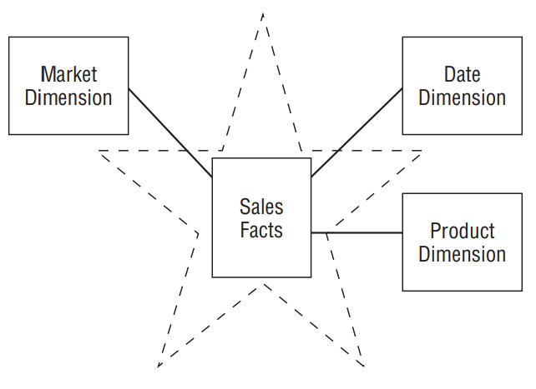
The (traditional) star schema consists of Dimension tables and a single Fact table.

Fact tables (measurements)
The fact table is normally a measurement of some observable thing that happened in the real-world, like a sales transaction in a shop.
Normally, it will have a date/datetime associated with it - but not always - and some numeric value (like a transaction amount) - but not always.
Fact tables are normally 'long and thin' - not many columns, but lots of rows.
The columns in a fact table normally represent: a datetime, a numeric value, OR a link to Dimension tables that provide more descriptive context about that particular row in the Fact table.

Dimension tables
Dimension tables normally contain fewer rows, and more columns. Examples of Dimensions tables could be:
- Product Dimension (details about each product sold in a store)

- Store Dimension (details about the different stores that a company owns/ trades from)

- Offer Dimension (details about a particular offer for a product).

- Date Dimension (this is a special case - for BI applications like Power BI, a single Date Dimension table connects to all your Date columns. This is useful for on-page filtering (i.e. a single date value that, when filtered, filters all other tables) and time intelligence calculations. We will create one of these in another tutorial.

